# (SS 2015)

## Course Monitoring

### Task 1: Sensors (13%)

1. Please name 3 different geodetic measurement techniques to determine height differences and give their standard deviations.

|  |
| --- |
| 1. Levelling (1mm/km) |
| 1. Total station (Distance 1mm+1ppm) (V 1 mgon) |
| 1. DPGNSS+Post-processing (1mm-2cm) |

1. Displacement transducers are often used for monitoring tasks. Please give 3 different realizations of the pick-off techniques.

|  |
| --- |
| 1. Resistive pick-off (potentiometer) 2. Capacitive pick-off 3. Inductive pick-off 4. Gauge |

1. Please describe the measurement principle of mechanical plumbing and give the achievable accuracy.

|  |
| --- |
| Mechanical plumbing is realized with the use of tensed wires connected from the top to the bottom of the structure. It is a free wire with a mass damping in some liquid (oil, water). The reading or pick off is realized near the mass, which can be placed in the bottom (normal pendulum principle) or in the top (inverted pendulum principle). |

### Task 2: Alignment and Measurement Concept (37%)

In seaports and container terminals across the world ship-to-shore crains are used for cargo handling. Your company obtains the assignment for an annual deformation measurement of the guide rails of the crain (Figure 1).

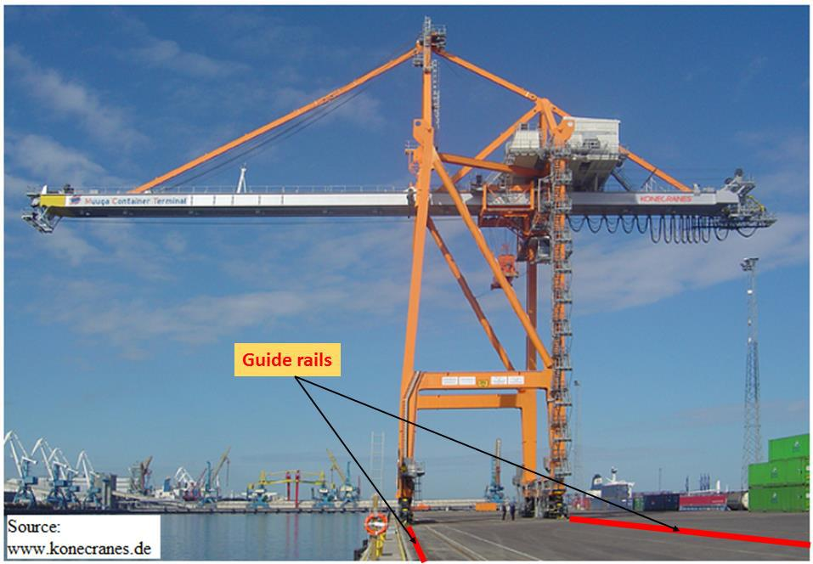

**Figure 1: Ship-to-Shore Crain**

You decide to apply the method of optical alignment for this specific monitoring task and subsequently conduct a two-epoch deformation analysis. Figure 2 displays the geometric situation:

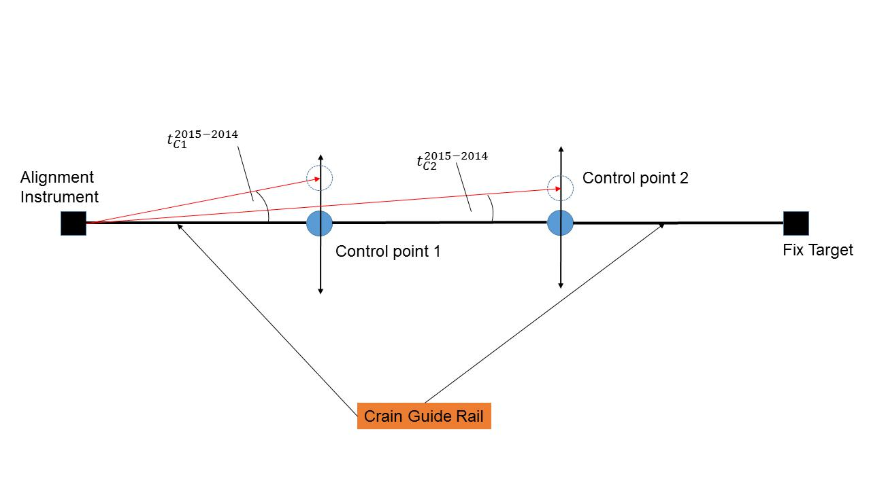

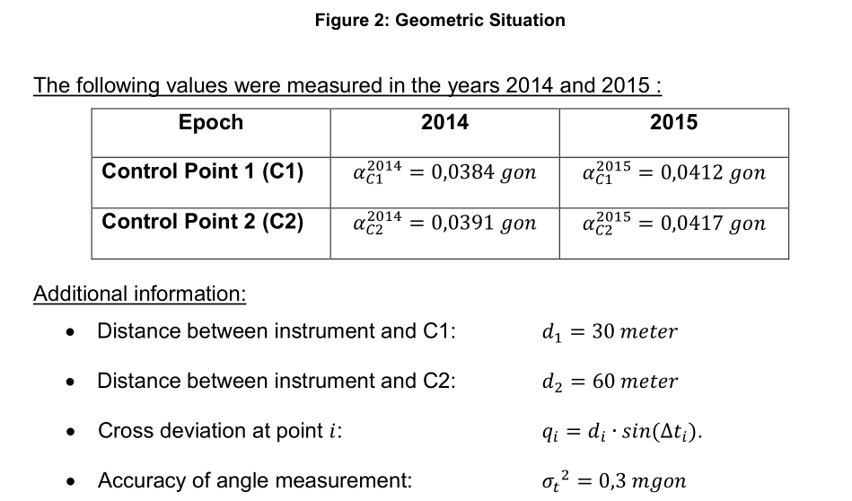

1. Please name 4 known deformation models taking into account time and influencing forces.

|  |
| --- |
| 1. Congruence 2. Static 3. Kinematic 4. Dynamic |

1. Please calculate the standard deviations of the cross deviations for control points C1 and C2. Apply the law of error propagation under consideration that distance measurements d1 and d2 are error free.

|  |
| --- |
|  |

1. Your client requires that the theoretical standard deviation should not exceed 1,0 mm. Please test whether your calculated standard deviation for control point 2 from subtask a) complies with the required theoretical standard deviation.

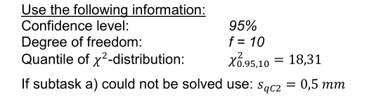

|  |
| --- |
|  |

1. Please design a measurement concept for this specific monitoring task.

Use the table below to extract the movement information of the crain guide rail from a-priori model. Specify all required formulas.

|  |  |
| --- | --- |
| **Period of deformation** | **Expected movement** |
| *daily (24 h)* | ∆ = 5 mm |
| *annually (365 d)* | ∆ = 10 mm |

d1) Please name the measurement quantity.

|  |
| --- |
| Length of the deflection w.r.t the track. |

d2) What kind of reference system would you like to choose?

|  |
| --- |
| Local refence system : 2D |

d3) Please name the possible causes of the deformation.

|  |
| --- |
| The load of the crane could cause the deflection. Temperature influence. |

d4) Please give the measurement interval.

|  |
| --- |
| Maximum (from annual period) = 2×10mm = 20mm |

d5) Which sampling rate would you recommend?

|  |
| --- |
| Sampling rate:  Daily: 24h/10 = 2.4h  Annual: 365d/10 = 37d |

d6) Please give a maximum epoch duration.

|  |
| --- |
| Daily: δt = Tp/100=(24×60min)/100=14min  Annual: δt = Tp/100=(365d)/100=4day |

1. Beside the optical alignment, also the method of mechanical alignment is existing. Please specify the two alignment methods under aspects of accuracies and automation.

|  |
| --- |
| Mechanical alignment 🡪 Acc. 0.03 to 0.1 mm 🡪 Automation YES  Optical alignment 🡪 Acc. 0.2 to 1 mm 🡪 Automation: NO |

## (SS2015) Course: Kinematic Measurement Systems

### Task 1: Robot Tachymeters (18%)

1. Modern robot tachymeters can be considered as multi-sensor systems. Please name 4 sensors that are integrated in the robot tachymeter.

|  |
| --- |
| Sensors:  -EDM  -Hz angles  -V angles  -Levelling sensors  -Pressure and temperature |

1. Programming of robot tachymeters is a favourable method to implement flexible and application-oriented measurement procedures. Therefore different programming languages can be used. A LabView programming code is given in figure 3. Please draw a flowchart diagram of the shown program. Specify the following parts of your flowchart diagram:

* Initialisation sequence
* Steering sequence
* Date storage

|  |  |
| --- | --- |
|  |  |

Figure 3: Block diagram of a tachymeter steering program

1. Please explain the difference between time delay/ dead time and synchronization error.

|  |
| --- |
| - Dead time is the time needed to communicate the data transmission.  - Synchronization error appears due the time difference between different durations of measurement sensors. (Reduced by starting the measurements at different times for each sensor) |

### Task 2: Further Kinematic Sensors (12%)

1. Beside tachymeters, GNSS often used for kinematic applications. Please indicate the error sources of GNSS.

|  |
| --- |
| Errors due to:  -Satellite orbit and clock  -Troposphere  -Ionosphere  -Antenna phase center |

1. Please name 3 further kinematic sensors and describe their characteristics under following aspects: -Measurement quantity -Accuracy

|  |  |  |
| --- | --- | --- |
| **Sensor** | **Measurement quantity** | **Accuracy** |
| GNSS | X,Y,Z coords | 3-10m |
| Tachymeter | X,y,z coords | <5mm |
| Photogrammetry cameras | X,y,z cords | 1mm |
| Gyroscope | Rotation rate | <0.01° |
| Inclination sensor | Inclination | <0.01° |

### Task 3: Modelling of Moving Objects (14%)

1. Please name 3 steering models for wheeled vehicles that were introduced in lecture.

|  |
| --- |
| 1. Two-wheel (front/rear) wheel steering 2. Four wheel steering 3. Articulated/combined steering |

1. Please give a process-scheme of a discrete linear Kalman Filter.

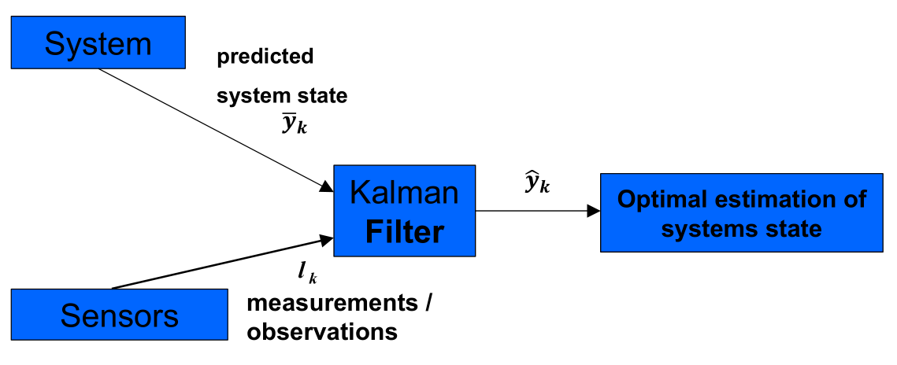

1. In Kalman Filters, the prediction of the system state is one of the main steps. Please give the formula for prediction step of the variance propagation within the Kalman Filter and identify the following matrices:

* Covariance matrix of the state vector
* Covariance matrix of the influencing forces
* Covariance matrix of the disturbance vector

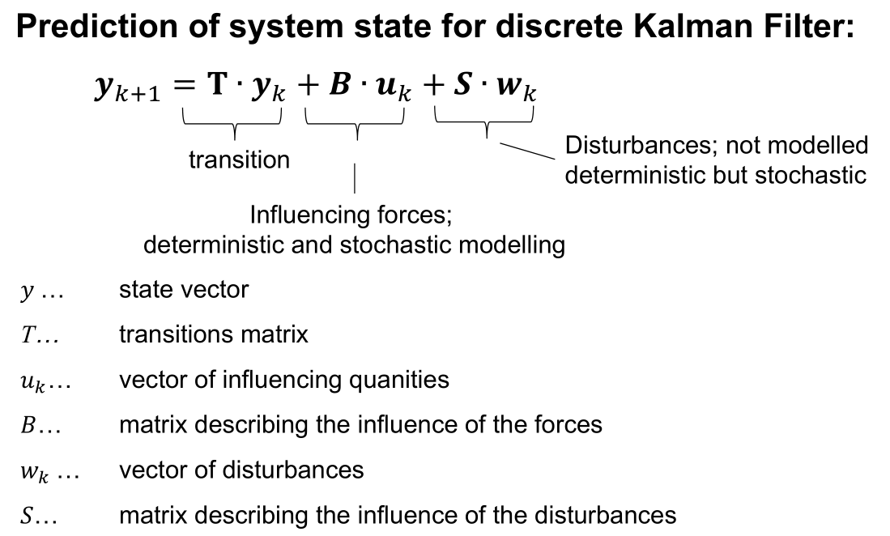

### Task 4: Classification of Guidance Systems (6%)

Guidance systems can be segmented into two groups: number of dimensions and degree of automation.

1. Please give the possible number of dimensions of guidance systems and name a measurement device for realization.

|  |
| --- |
| 1. 1D-systems (rotational laser)   Height controlled   1. 1.5D-systems (rotational laser + inclinometer)   Height + slope controlled   1. 3D-system (Total Station - GNSS)   Height + slope + horizontal position controlled |

1. Please classify the guidance systems according to the degree of automation. Give a short explanation for each of them.

|  |
| --- |
| 1. Indicative system   Steering indications are given but operator controls the machine   1. Semi-automatic system   Height + slope are automatically controlled, the other variables are up to the driver   1. Automatic system   The whole system is automatically controlled. (Height + Slope + Position) |